1. **Configure 2 slave machines in jenkins master.**

**Create 2 instances with slave 1 & 2 . and install java in slave 1**

* **Login to slave machine..**
* **switch to root user**
* **install jdk 11 (amazon-linux-extras install java-openjdk11)**
* **Create ssh-keygen**
* **Cd .ssh**
* **ls**
* **cat id_rsa.pub > authorized_keys**
* **chmod 700 authorized_keys**

* **Login to master machine**
* **switch to root user.**
* **mkdir -p /var/lib/jenkins/.ssh**
* **cd /var/lib/jenkins/.ssh**
* **ssh-keyscan -H SLAVE-NODE-IP-OR-HOSTNAME >>/var/lib/jenkins/.ssh/known_hosts**
* **# ssh-keyscan -H 172.31.38.42 >>/var/lib/jenkins/.ssh/known_hosts**
* **chown jenkins:jenkins known_hosts**
* **#we need to change the owner as we ran ssh-keyscan command using “root” user.**
* **# default user of Jenkins will be “jenkins”**
* **chmod 700 known_hosts**

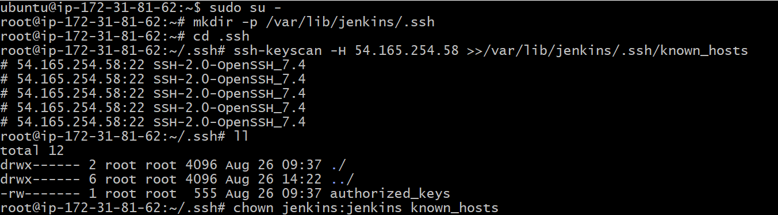

**Steps to be done on jenkins GUI:**

**========================**

**Go to manage jenkins**

**open manage node**

**under launch method select "Launch via SSh"**

**Host "public ip of slave"**

**creditals: select user with private key**

**enter ec2-user as name and paste the pem key.**

**host key verification startegy to be selected**

**save..**

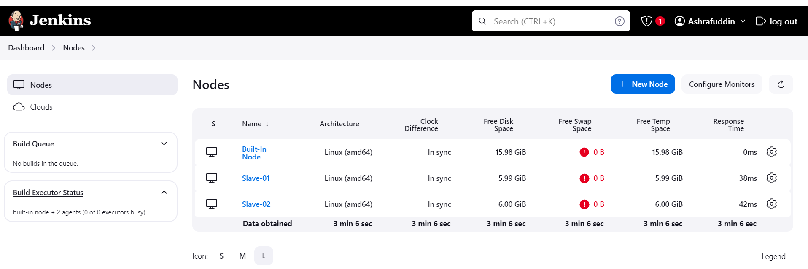

1. **Configure webhooks to jenkins job.**

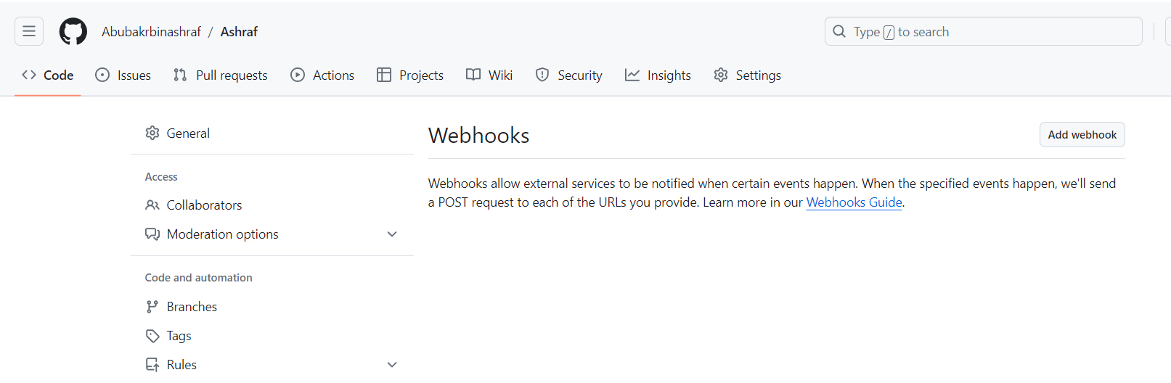

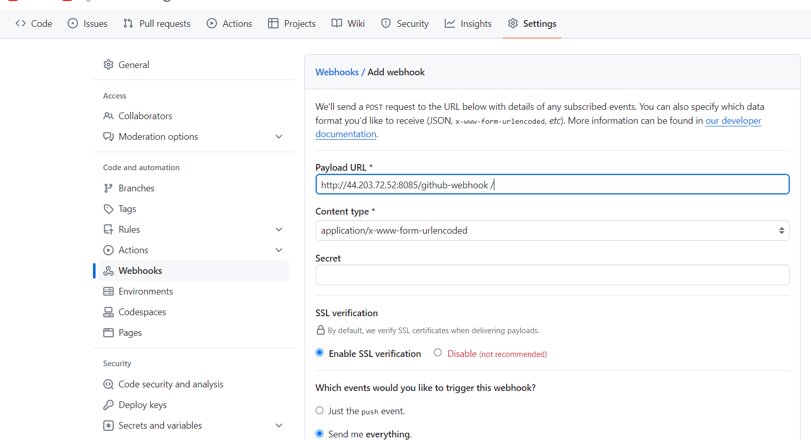

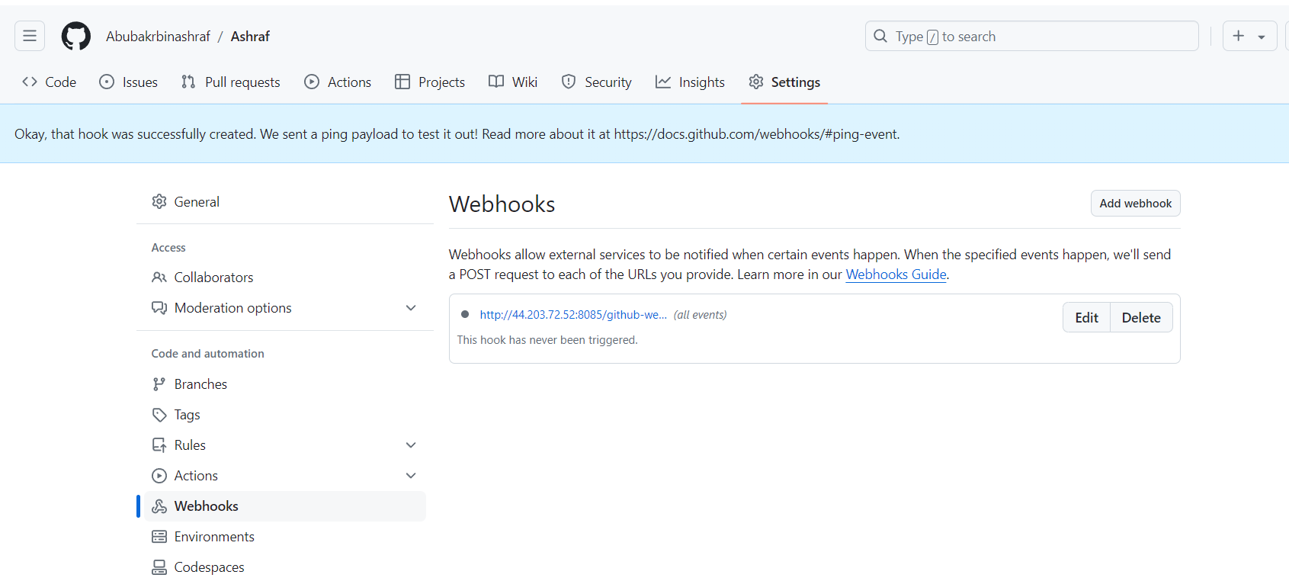

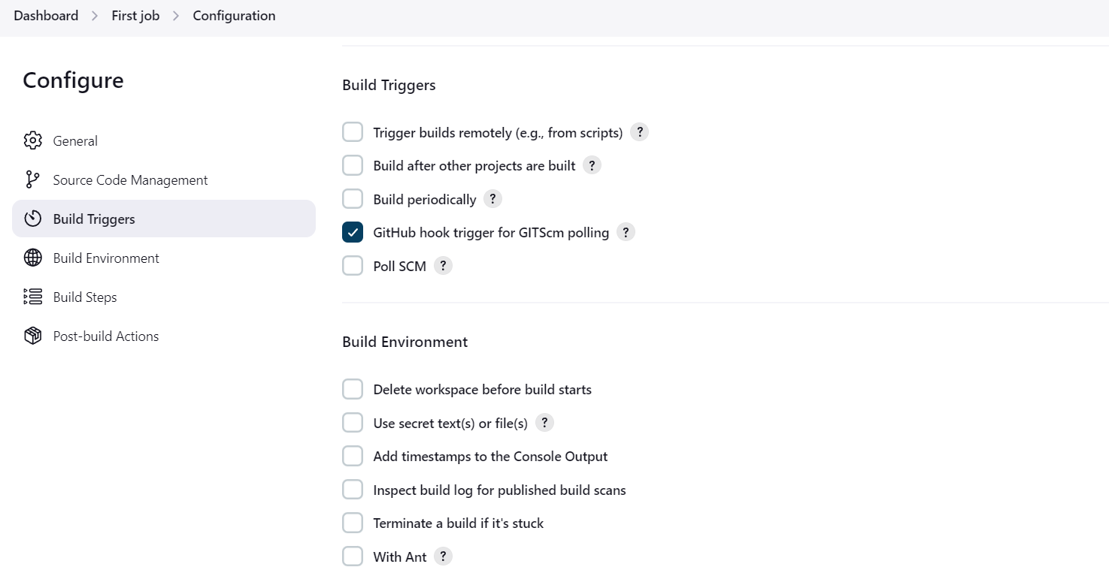

**Do some changes in git-hub account file and commit**

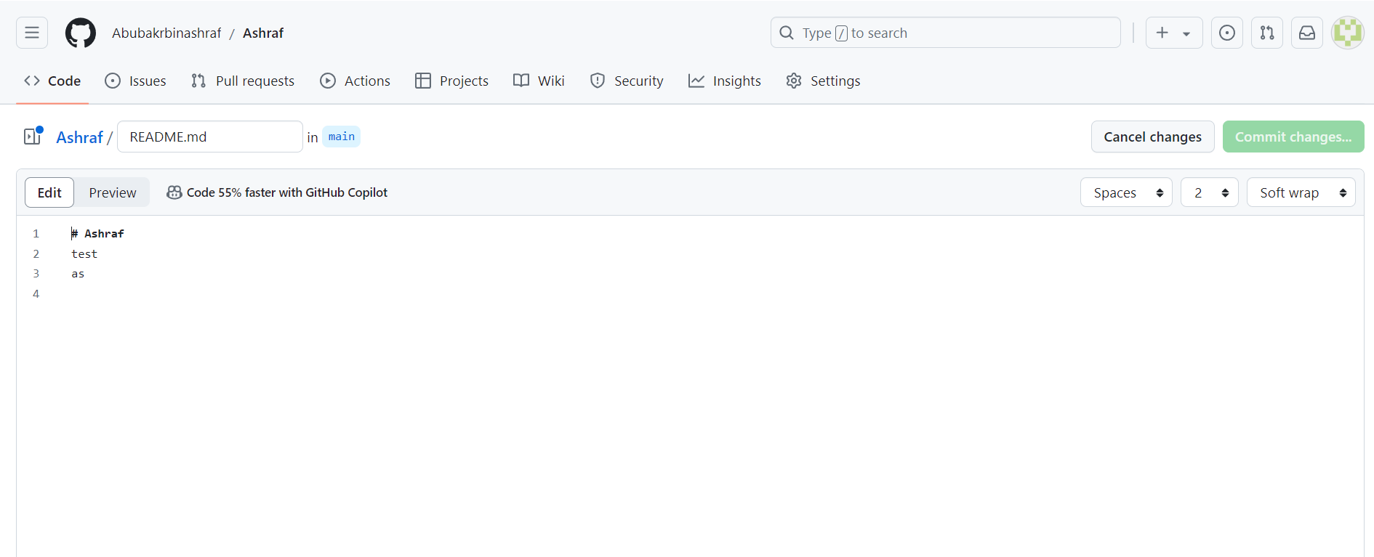

1. **Configure poll scm and build periodical options in jenkins job.**

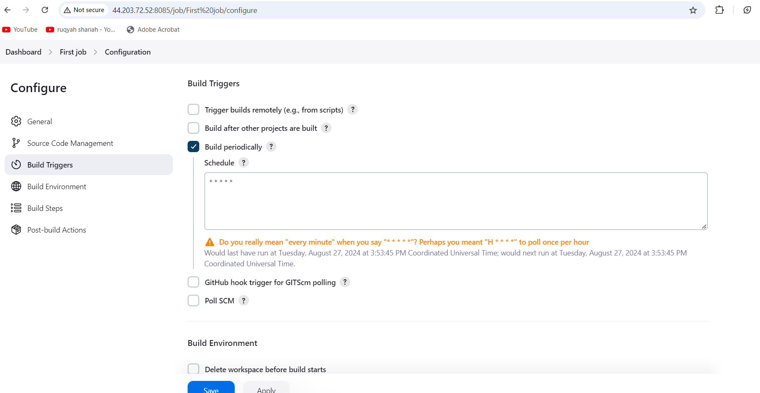

**For pollscm we need to do changes in git hub account then only it trigger for every 1 minute**

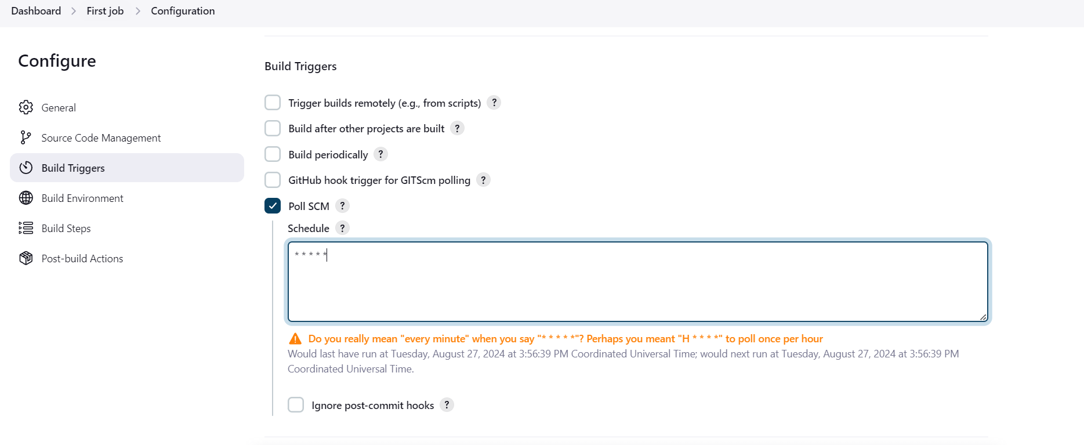

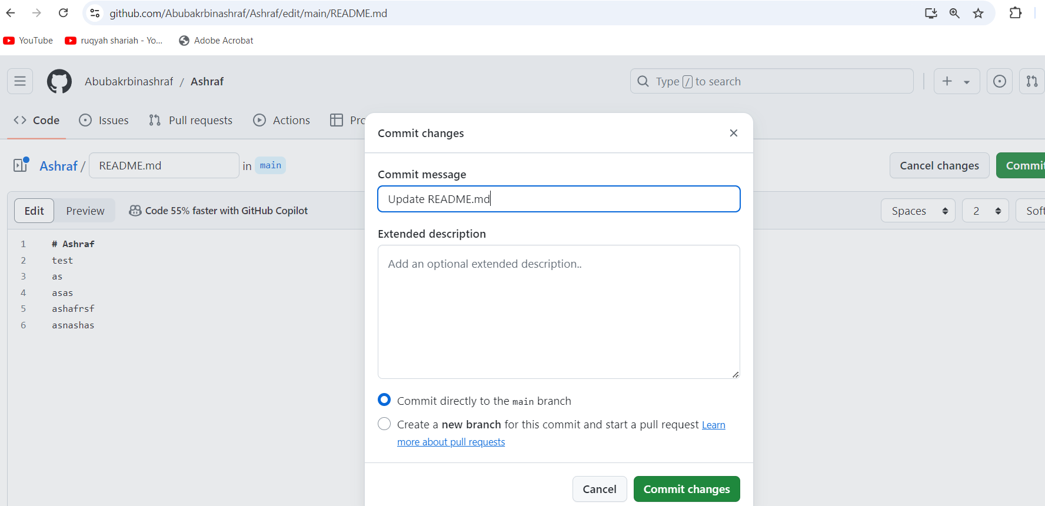

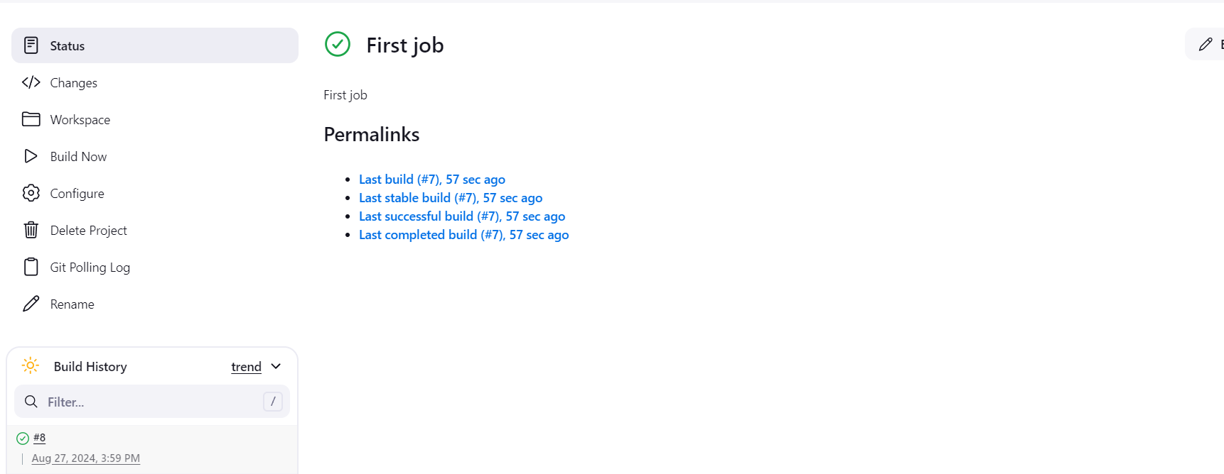

1. **Take backup of Jenkins server by using bash script.**

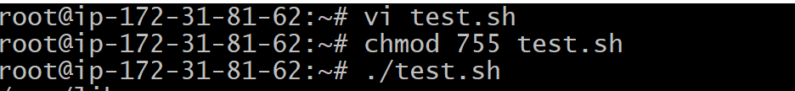

1. **Take backup of Jenkins using rethin backup plugin.**

**6) Setup a new Jenkins server and dump the backup taken in task4.**

**Create a new Ec2 instance and install Jenkins and java**

**Prerequisite to Install jenkins is java.**

**Download jenkins Repo:**

**=====================**

**sudo wget -O /etc/yum.repos.d/jenkins.repo https://pkg.jenkins.io/redhat-stable/jenkins.repo**

**Import the jenkins key:**

**======================**

**sudo rpm --import https://pkg.jenkins.io/redhat-stable/jenkins.io-2023.key**

**Update ec2:**

**==========**

**sudo yum upgrade**

**Add required dependencies for the jenkins package:**

**=================================================**

**sudo amazon-linux-extras install java-openjdk11**

**Install Jenkins:**

**===============**

**sudo yum install Jenkins**

**Now backup the file from master Jenkins by copying pem key to connect to the backup server**

**Tar -cvf backup.tar Jenkins/**

**Tar xvf Jenkins_backup.tar**

**After this restarts the Jenkins in backup server**

**Now you can see the jobs which you have created in master Jenkins as below in the backup server**

